**State(10):**

State is nothing but a object which privately maintain inside a component,state is influence what is render inside a component,state can be change within the component.(in Class Component as it is a object).

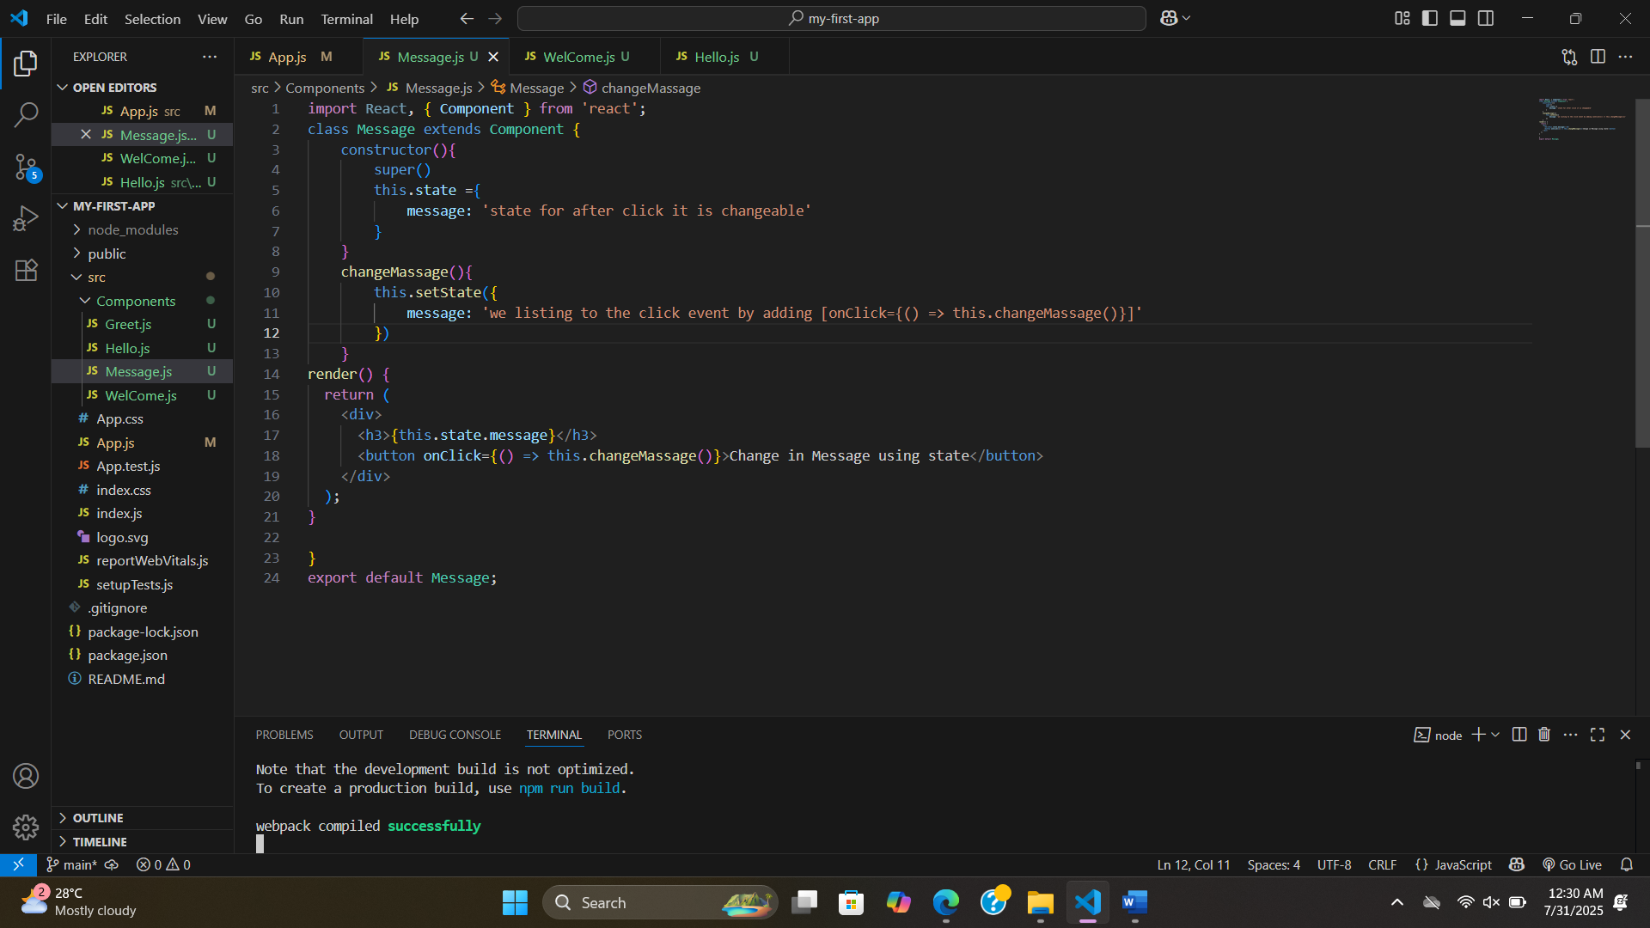

**SetState(11)[Dos and don’ts]:**

**Without setState:**

**Here console showing the increment ,but in UI did not showing increment.**

**With setState but not async:**

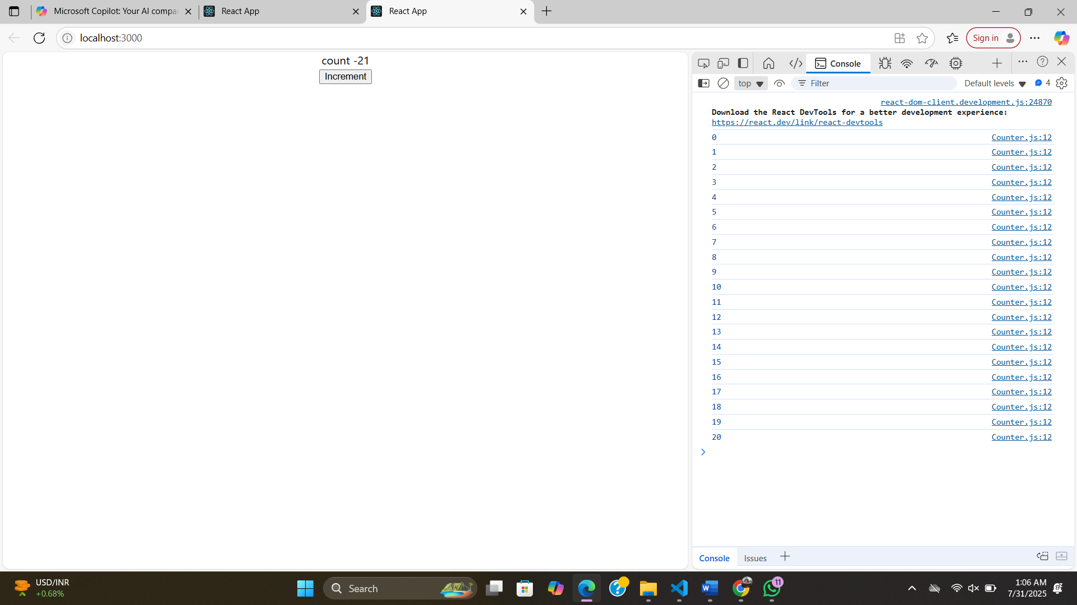

**Soo with callback as second perameter:**

**Case 2:**

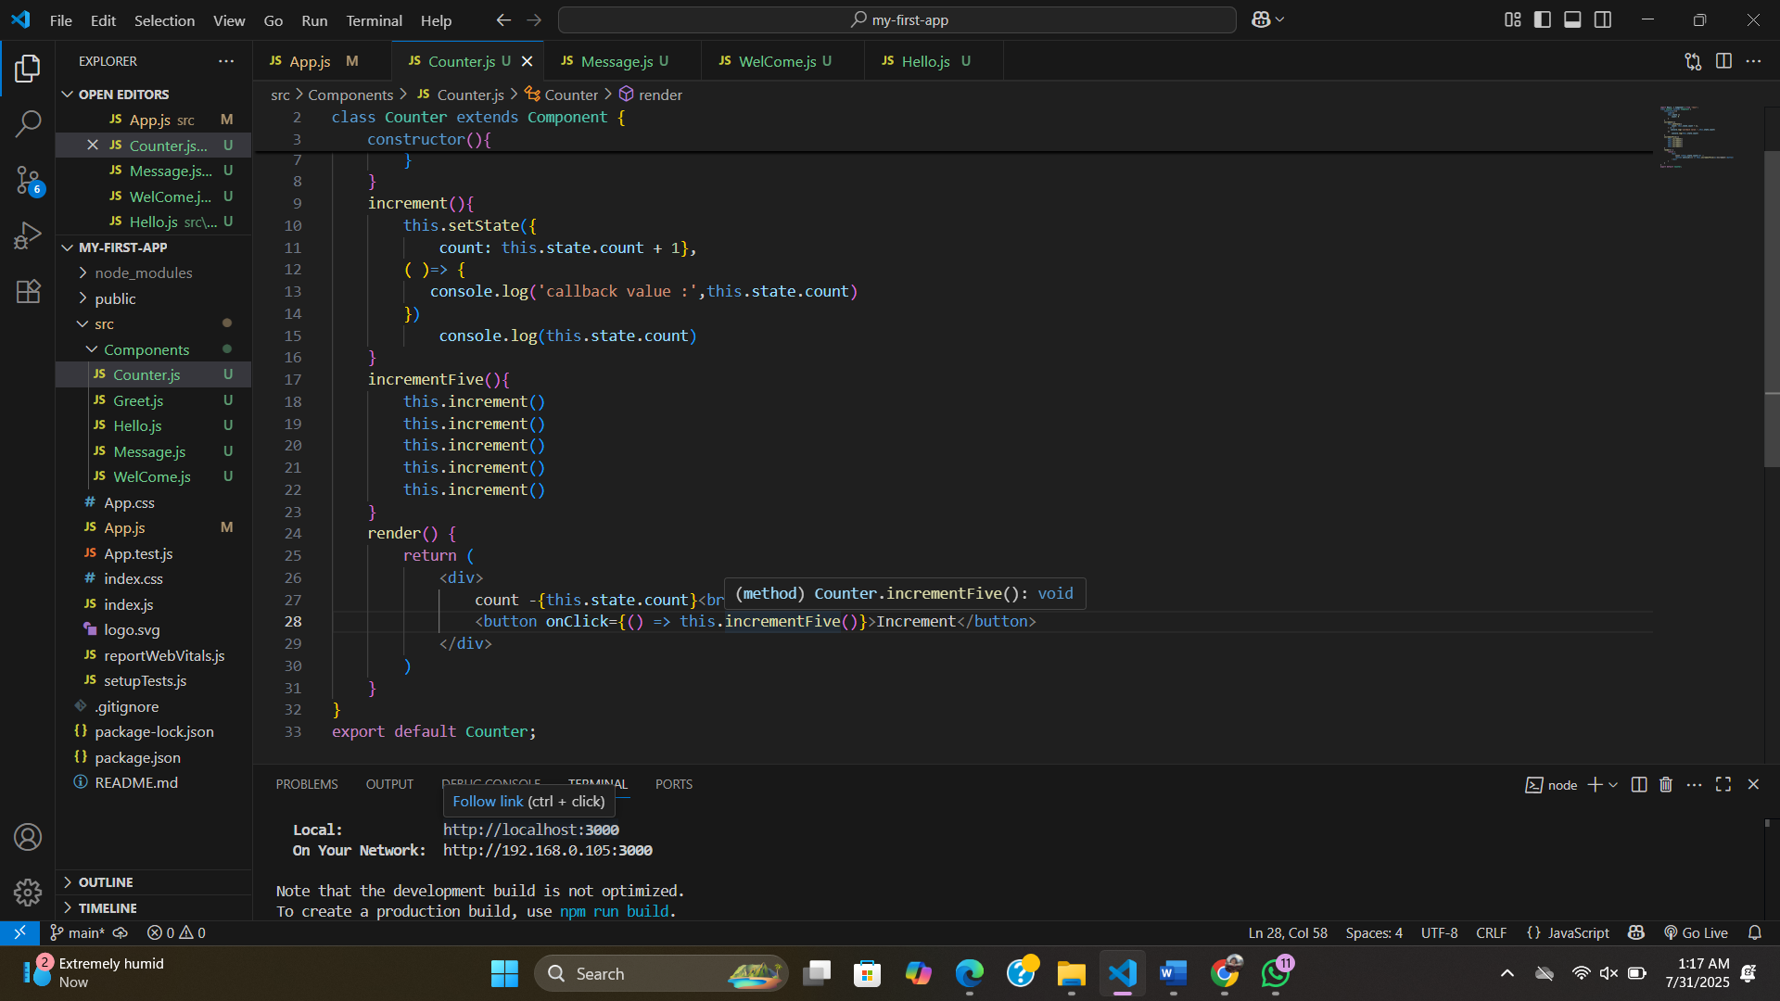

**We can see the value is changes to 1 not by five so to avoid:**

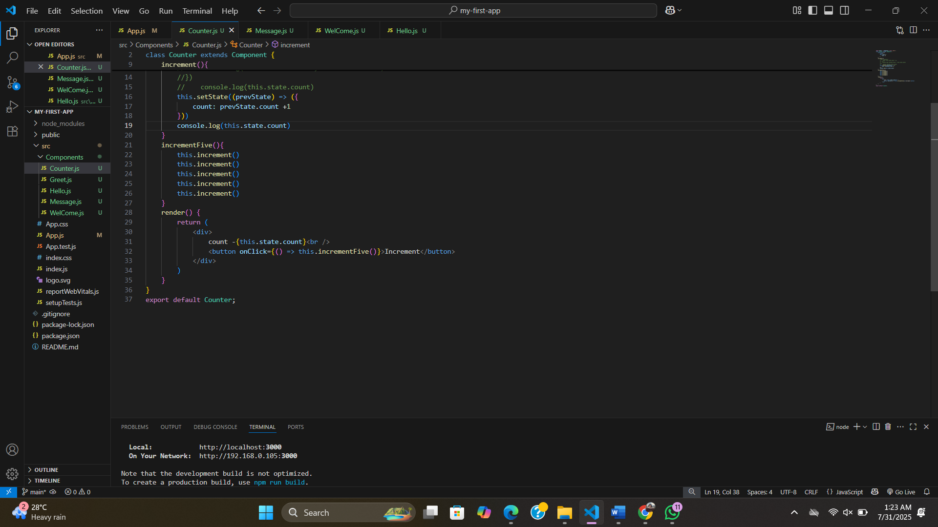

**setState:**

* Always make use of setState and never modify the state directly.
* Code has to be executed after the state has been updated ? Place that code in the call back function which is the second argument to the setState method.
* When you have to update state based on the previous state value, pass in a function as an argument instead of the regular object.